LCM Spring Music Festival and Fundraiser

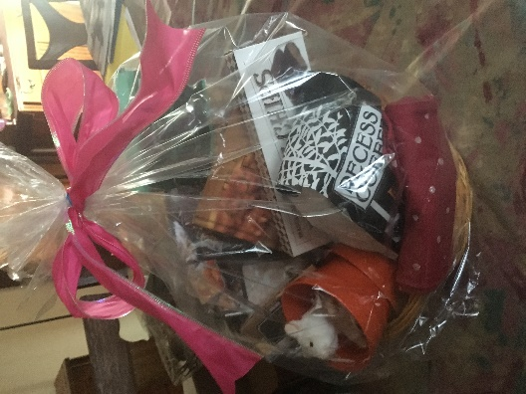
Thank you for your generous support.

We raised over $3000 this year to support our mission to share the good news of God’s love on campus and connect students to opportunities to serve all God’s people.
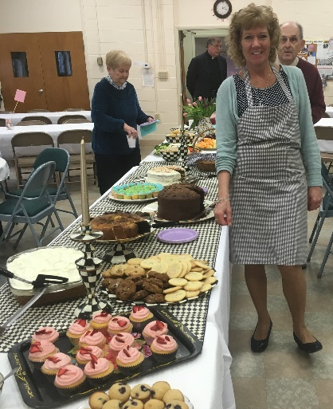
Thanks to St. Paul’s Lutheran Church in Liverpool for hosting and to David and Cheryl West for coordinating their hospitality. Thanks to Don Doerr for encouraging everyone’s generous bids. Thanks to all our bakers and chefs, especially Mary Webb, Joyce Bresnahan, freshman student Sara Haynes, and Cheryl West.
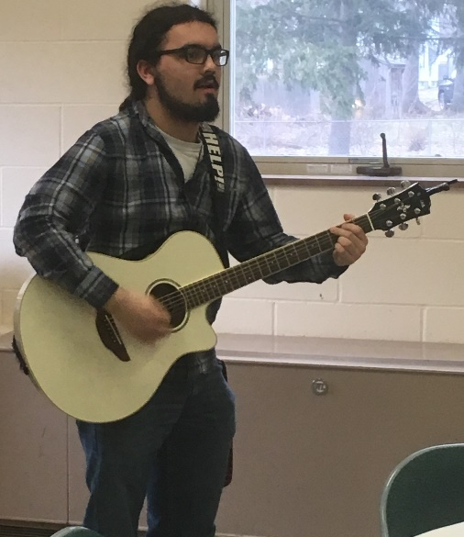
Ross Chua, LCM Musician
Playing original song

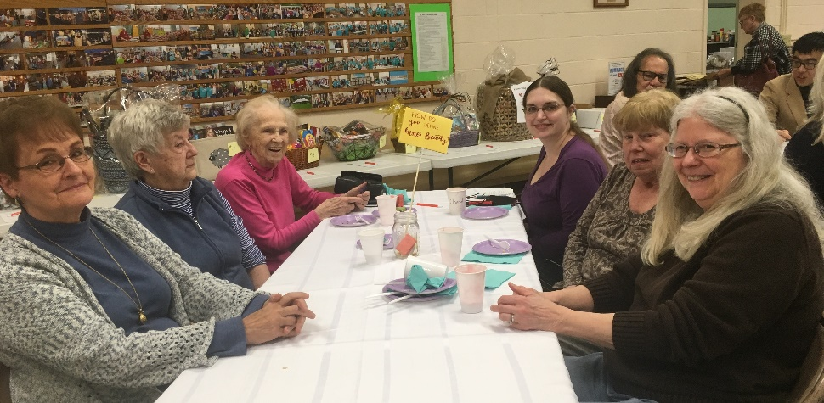
Thanks to everyone who was able to come and join in the great fellowship!

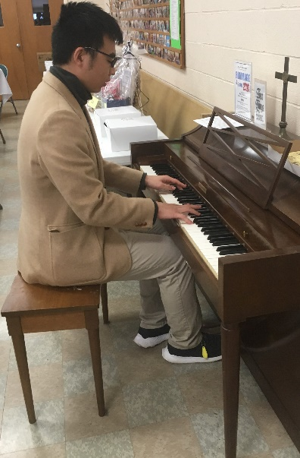
Senior William Shaw playing Chopin

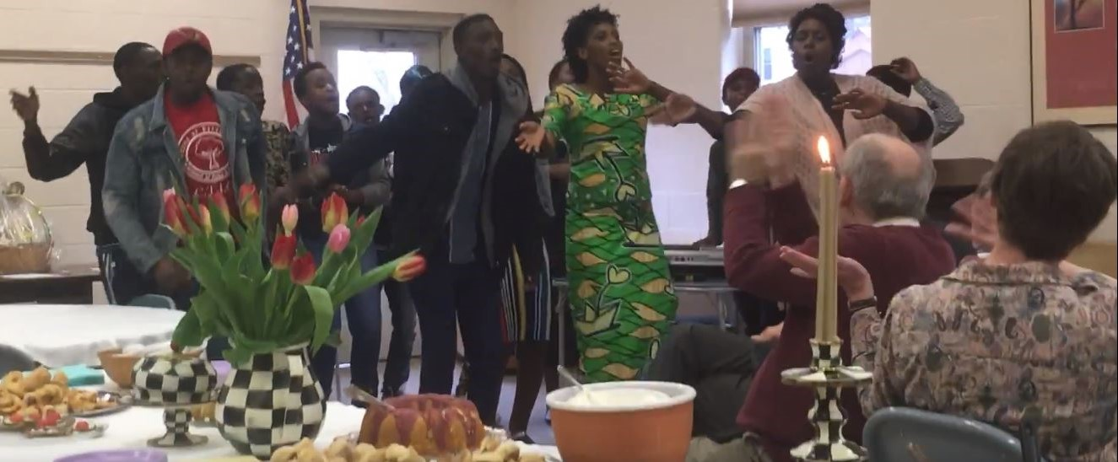
Heaven’s Melody youth choir we met through our outreach work with the Congolese New American community makes a joyful noise.

